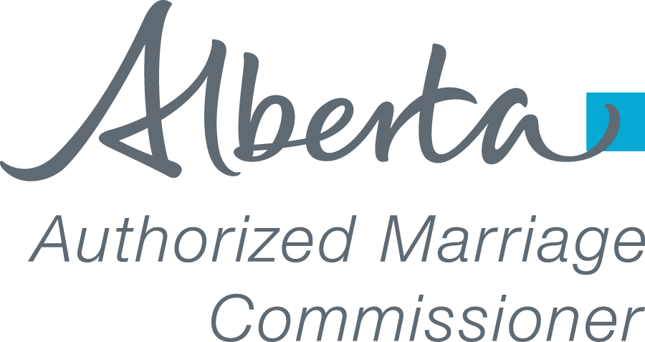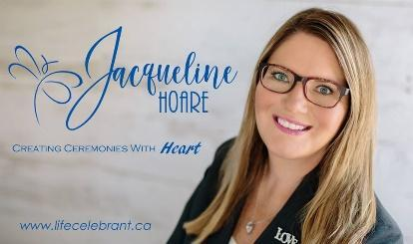
JACQUELINE HOARE
Life Celebrant ~ Creating Ceremonies with Heart

220 Oakmoor Place SW ⬥ Calgary, AB T2V 4A4 ⬥ (403) 818-6430 cell ⬥ www.lifecelebrant.ca ⬥ jacqueline@lifecelebrant.ca
THIS AGREEMENT, entered into on this date , ____ for the services of Jacqueline Hoare, Marriage Commissioner for the Province of Alberta and and referred to as the marriage partners in this letter of agreement. Wedding Planner: Referred By:
MARRIAGE PARTNER 1 |  | MARRIAGE PARTNER 2
First / Middle Name: |  | First / Middle Name:
Last Name: |  | Last Name:
Mailing Address: |  | Mailing Address:
City / Prov / Postal: |  | City / Prov / Postal:
Home Phone: |  | Home Phone:
Cell Phone: |  | Cell Phone:
E-Mail: |  | E-Mail:

YOUR WEDDING CEREMONY– Date, Time & Venue
The Wedding Ceremony will take place in , Alberta on , , 2024. The ceremony will begin at o’clock at the following location;
Full Name of Wedding Venue Please ATTACH a Map to your Venue if Rural Address
Address of Venue Phone # of Venue ** or personal cell # **ESSENTIAL**
(Note: Once your booking is confirmed, it is imperative you notify me ASAP if your ceremony time changes☺)
YOUR WEDDING REHEARSAL
☐ Marriage Commissioner’s participation at the Wedding Rehearsal is requested and will take place at on , 2024. The rehearsal will begin at o’clock. (There is an additional $175.00 fee if you require Jacqueline Hoare’s participation at your Wedding Rehearsal).
YOUR WITNESSES - These are two adults who will be the witnesses at your wedding ceremony.
The following information is required for the legal marriage registration.
WITNESS for Marriage Partner 1 |  | WITNESS for Marriage Partner 2
First Name: |  | First Name:
Last Name: |  | Last Name:
Mailing Address: |  | Mailing Address:
City / Province: |  | City / Province:
Postal Code: |  | Postal Code:
Daytime Phone #: |  | Daytime Phone #:

FEES FOR SERVICES PERFORMED (5% GST is added to all services)
Marriage Commissioner Fee: | $ 450.00 | Includes; Pre-Wedding Planning Meeting and personalized ‘Wedding Ceremony’, and travel mileage within the city limits; you will receive an interim Marriage Certificate, a Keepsake copy of your Wedding Ceremony, and I will submit your completed Marriage Licence/Registration to Vital Statistics.
Legal Ceremony at my Location: | $ 325.00 | Includes: Elopement/Legal Ceremony in my home, you will receive an interim Marriage Certificate, a Keepsake copy of your Wedding Ceremony, and I will submit your completed Marriage Licence/Registration to Vital Statistics.
Vow Renewal: | $ 450.00
Rehearsal Fee: | $ 300.00 | Optional: Marriage Commissioner’s participation at Wedding Rehearsal. I will assist in a smooth run through of your wedding ceremony with you and your attendants.
Additional Expenses: |  | Travel Expenses: Mileage expenses incurred if your Wedding venue is outside of the city limits and is calculated at .68¢/km from the city centre and return plus $80.00 per hr travel time.
 | $ 25.00 | Parking: Applies when parking expenses are incurred when it is necessary for pay parking in hotel parkade or pay lot.
 | $175.00 | Sound System: $175.00 fee for use of sound system for ceremony (setup and takedown included).
 | $35.00 | Witnesses: All efforts will be made to arrange for witnesses with adequate notice at $35.00 per witness as required.
 | $80.00 | Rush Registration: Completed Marriage registration will be hand delivered and processed at registry $80.00.
Booking Retainer: | $ 200.00 | An initial non-refundable payment of $200 is required immediately to guarantee your wedding date and time along with this signed Agreement. Balance to be paid at planning meeting prior to ceremony.
NOTE: Please make a copy of this Agreement for your files
We, the signing Marriage Partners, having read and agree to the terms detailed herein, our signatures affirm our contract with Jacqueline Hoare, Marriage Commissioner for the Province of Alberta.

___________________________________/___/___ _______________________________/___/___
Marriage Partner 1 Signature ^{month day year} Marriage Partner 2 Signature ^{month} ^{day year}

(You may type your name and date for an electronic signature)

Please complete and return by email to jacqueline@lifecelebrant.ca

OFFICE USE ONLY
❑ Agreement & ❑ Retainer Received  ❑ Booking Entered into Calendar & ❑Wave Accounting  ❑ Pre-Wedding Meeting Booked _____________  ❑ Draft Ceremony Sent  ❑ Invoice & Rehearsal Plan Emailed  ❑ Ceremony Approved | ❑ Ceremony Printed  ❑ Marriage Licence Received  ❑ Registry & Licence Filled In  ❑ Marriage Statement Written  ❑ Completed & Submitted to Alberta Vital Statistics  ❑ Final Payment Received

JACQUELINE HOARE
Life Celebrant ~ Creating Ceremonies with Heart

220 Oakmoor Place SW ⬥ Calgary, AB T2V 4A4 ⬥ (403) 818-6430 cell ⬥ www.lifecelebrant.ca ⬥ jacqueline@lifecelebrant.ca
WEDDING INFORMATION
THIS IS VERY IMPORTANT INFORMATION FOR YOUR WEDDING DAY!

IT IS ADVANTAGEOUS FOR YOU TO READ THIS IMPORTANT INFORMATION TOGETHER. The following information has been passed on to me and is the result of many years of experience and caring. It is critical that everyone understands their responsibilities in order that you have a most memorable, warm and happy experience possible. Please know that Jacqueline is open to your ideas with regards to your vows and readings. Once you have signed the Letter of Agreement, I know you will be accountable for what has been agreed to herein; so that your wedding day is everything you want it to be and more. (Please take the time to focus on this material; and I ask that this information be given your full attention for your signatures on the contract are based on it!)
PLEASE BRING THIS DOCUMENT TO YOUR PRE-WEDDING MEETING!
- PUNCTUALITY
- IT IS CRITICAL that you BOTH arrive at the location of your wedding venue no later than twenty (20) minutes PRIOR TO THE CEREMONY to ensure your ceremony starts on time.
- Your wedding ceremony will never be rushed, however, I may have to leave immediately following the ceremony.
- FEES, CONFIRMATIONS, TIME CHANGES, CANCELLATIONS
- The fee for services performed by Jacqueline Hoare for a wedding ceremony will be $450.00 which includes your Pre-Wedding Planning Meeting (book one month prior to wedding), your personalized Wedding Ceremony and travel mileage within the city limits and you will receive an interim ‘Civil’ Marriage Certificate and a keepsake copy of your Wedding Ceremony. I will submit your completed Marriage Licence to Vital Statistics. 5% GST is added to all services.
A $200.00 initial non-refundable payment is required immediately to confirm and guarantee your wedding date and time. Email Money Transfers, Cash or Personal cheques are accepted for the booking payment. Please make cheque payable to JACQUELINE HOARE and send to 220 Oakmoor Place SW, Calgary, Alberta T2V 4A4. If sending an Email Money Transfer, I have set up auto deposit, but if you are required, please use the ‘month of your Wedding’ as the ‘security question’ and send to email jacqueline@lifecelebrant.ca .
- Final payment in Email Money Transfer, cash or post dated cheque is due prior to your ceremony either at the ‘Pre-Wedding Planning Meeting’ or on ‘Your Wedding Day’ prior to ceremony and should be left on the signing table or with a designate. (Payment after the Ceremony is very awkward for all!)
- Additional Expenses - Travel expenses are incurred if your Wedding venue is outside of the city limits and is calculated at $0.68/km from the city centre and return plus $80.00 per hour. (To be calculated on Google Maps). Parking expenses ($25.00) are incurred if it is necessary for pay parking in Hotel parkade or pay lot, as well as the Banff National Park entrance fee. All efforts will be made to arrange for witnesses with adequate notice at $35.00 per witness as required.
- There is an additional $300.00 fee if you require Jacqueline’s participation at your wedding rehearsal. The purpose of the rehearsal is for the participants to practice the processional, the recessional, and any of the parts of the ceremony during which timing is critical. It is not necessary to practice the vows at the rehearsal, (you cannot practice how you feel for each other). Jacqueline goes into the service first and comes out last. In place of the marriage commissioner at the rehearsal, you can have a stand-in. I do provide a ‘Rehearsal Plan’ at no charge if you wish to have someone else run the rehearsal.
- Unforeseen circumstances DO happen. If this should occur, Jacqueline will assist in securing the services of another Marriage Commissioner. (Please Note: This is an extremely rare occurrence.)
- If indeed your plans alter or change, please allow reasonable time so your request(s) and the requests of others can be accommodated. (Note: Once your booking is confirmed, it is imperative you notify me ASAP if your ceremony time changes☺)
- MARRIAGE LICENCE – PLEASE BRING TO THE PRE-WEDDING PLANNING MEETING!
(Please note that you are required to purchase a Marriage Licence at a Registry Office and have the ceremony performed within 90 days of the Licence issue date).
- Jacqueline would like to see you and your attendants briefly just prior to your ceremony. Separately, of course, if you wish to remain ‘unseen’. Someone can let me know where to find each of you.
- Your Marriage Certificate, the Provincial Register and the Legal registration MUST be signed immediately during the ceremony by both of you as well as the two ADULT (18 years of age) witnesses. Please have a table available for the signing beside the ceremony location. Jacqueline will mail your signed registration to the Vital Statistics office in Edmonton. (You may order a legal Certificate of Marriage from your Registry within 3 weeks, if you wish).

- LOCATION – VENUE
  - If you wish to marry outdoors, in a public, rural or unusual place, please have a clear detailed map of the EXACT location. If your venue is in a new part of the city, please provide directions and a map.
  - You MUST have a Plan B if weather is inclement (with map and directions). Please attached with your Letter of Agreement.
  - If you have any questions WHATSOEVER regarding location or weather, it is imperative you phone me the morning of your chosen day. Please have your cell phone on for me to call if delayed. My cell phone number is 403-818-6430.
- WEDDING FORMAT
All of the plans regarding the processional, recessional, the music, any readings and any other details are completely up to you. Advice is available regarding the processional or recessional.
Once your date and time has been scheduled & the attached Agreement (plus Retainer) has been received, all other arrangements may be made by telephone or email until your pre-wedding planning meeting. I will call or email you to inform you of receipt of your Retainer & Letter of Agreement. Please contact me one month prior to your ceremony to set up an appointment for your pre-wedding planning meeting. Feel free to call me at 403-818-6430 if you have any questions & I will be happy to give you all the help I can.
Send Letter of Agreement & Retainer to:  Jacqueline Hoare  220 Oakmoor Place SW  Calgary, AB T2V 4A4  Phone: (403) 818-6430 | Address for Pre-Wedding Planning Meeting:  House #220, 200 Oakmoor Place SW  Calgary, AB  (West on Southland Drive to the intersection on Oakfield Drive make three (3) right hand turns and you are on my crescent 200 Oakmoor Place, my house number is 220) Phone: (403) 818-6430. Please do not park in the driveway, there is street parking around the green space island.
Please review this information the week of your wedding! This is your special wedding day – it is advisable to keep this information, your marriage Licence and a copy of the Letter of Agreement in a wedding file in a safe place and easy to refer to in order for you to be well prepared.
**PLEASE BRING YOUR MARRIAGE LICENCE TO THE PRE-WEDDING PLANNING MEETING**
Please Note –
- Re-Read – Section II (Fees, Confirmations, Time Changes, Cancellations)
- It is unlawful to be married without a valid Licence.
- It is unlawful to be married while under the influence of drugs or alcohol.
- It is unlawful to be married without two adult witnesses.
- If you require further information on getting married in the Province of Alberta . . . go to this Alberta Government link https://www.alberta.ca/getting-married.aspx

I look forward to sharing your Wedding Day with you!
Jacqueline Hoare
